Postal Life Insurance

Department of Post

Software Requirements Specification (SRS)/ Functional Requirements Specification (FRS)
  - GenAI Consumption

INTERNAL APPROVAL FORM

Project Name: GenAI Consumption
Version: 1.0
Submitted on:
 | Name | Date
Approved By:
Reviewed By:
Prepared By:

VERSION CONTROL LOG
Version | Date | Prepared By | Remarks
1

Table of Contents

1. Executive Summary 4
2. Project Scope 4
3. Business Requirements 4
4. Functional Requirements Specification 5
4.1 Use Case 1: Intelligent Underwriting 5
4.2 Use Case 2: Automated Claims Processing 5
4.3 Use Case 3: Personalized Communication 6
4.4 Use Case 4: Advanced Chatbot 6
4.5 Use Case 5: Fraud Detection 6
4.6 Use Case 6: Product Development 6
4.7 Use Case 7: Agent Support 6
5. Attachments 6

1. Executive Summary
The purpose of this document is to define requirements for integrating Generative AI (GenAI) capabilities into Insurance Management System to enhance automation, personalization, and operational efficiency across life insurance processes.

2. Project Scope
This Module will:
- Enable intelligent underwriting, claims processing, and fraud detection.
- Provide personalized customer communication and advanced chatbot interactions.
- Support agents with portfolio insights and assist in product development.
- Generate synthetic datasets for risk simulation and pricing optimization.
- Integrate securely with IMS Core, CRM, and external AI services.

3. Business Requirements

ID | Requirements
FS_GAI_001 | The system shall leverage GenAI to automate underwriting and provide accurate risk scoring for new policy applications.
FS_GAI_002 | The system shall use GenAI to summarize claim documents and assist in faster claims processing.
FS_GAI_003 | The system shall generate personalized, multilingual customer communication for policy updates and reminders.
FS_GAI_004 | The system shall enable GenAI-powered chatbots to handle FAQs, onboarding, and guided claim submissions.
FS_GAI_005 | The system shall utilize GenAI for fraud detection by identifying anomalies in claims and transactions.
FS_GAI_006 | The system shall support product development and pricing simulations using synthetic data generated by GenAI.
FS_GAI_007 | The system shall provide AI-driven insights to agents for portfolio analysis and cross-sell opportunities.
FS_GAI_008 | The system shall create and maintain internal knowledge bases and training content using GenAI.

4. Functional Requirements Specification

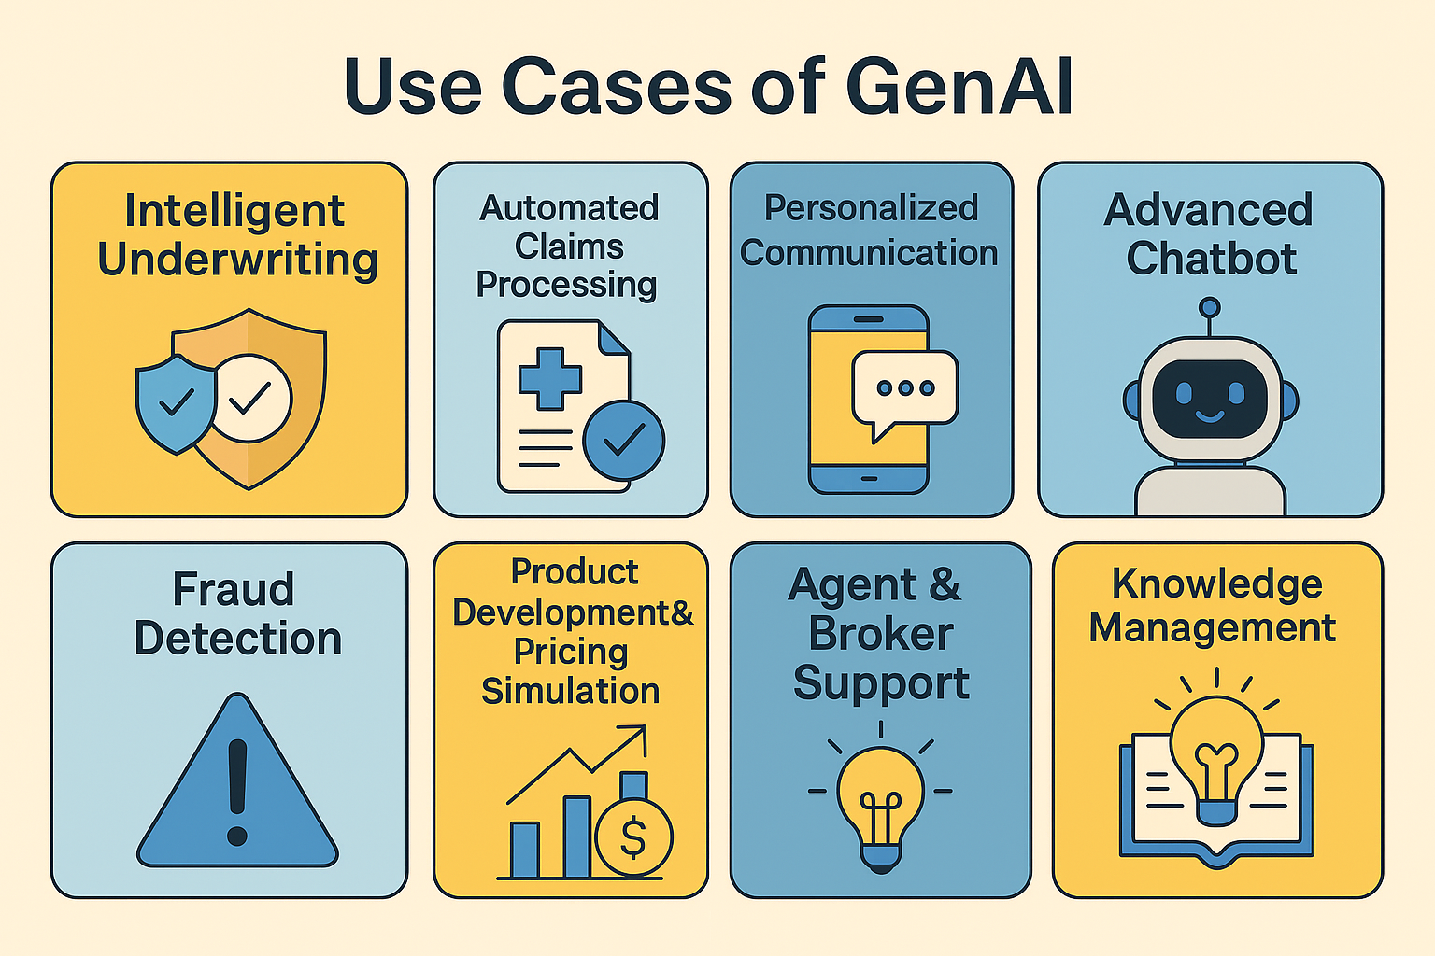

4.1 Use Case 1: Intelligent Underwriting
- Actor: Underwriter
- Trigger: New policy application
- Flow: AI analyzes applicant data → Generates risk score → Suggests premium.

4.2 Use Case 2: Automated Claims Processing
- Actor: Claims Officer
- Trigger: Claim submission
- Flow: AI summarizes documents → Flags anomalies → Suggests approval/escalation.

4.3 Use Case 3: Personalized Communication
- Actor: Policyholder
- Trigger: Premium due reminder
- Flow: AI generates multilingual email/SMS → Sends via Notification Engine.

4.4 Use Case 4: Advanced Chatbot
- Actor: Policyholder
- Trigger: Customer asks “How do I submit a claim?”
- Flow: AI chatbot provides guided steps → Offers link → Escalates if needed.

4.5 Use Case 5: Fraud Detection
- Actor: Compliance Officer
- Trigger: Claim processing
- Flow: AI detects anomaly → Generates fraud alert → Logs for audit.

4.6 Use Case 6: Product Development
- Actor: Product Manager
- Trigger: New product design
- Flow: AI simulates risk scenarios → Suggests pricing → Generates synthetic data.

4.7 Use Case 7: Agent Support
- Actor: Insurance Agent
- Trigger: Customer portfolio review
- Flow: AI suggests upsell opportunities → Provides personalized scripts.

5. Attachments
The following documents can be referred.

